Business Studies

Grade 11

Business Environment, Business Sectors (RECAP)
& Team performance

Business Environment
RECAP: BUSINESS ENVIRONMENTS
MICRO ENVIRONMENT (forces inside business- full control):
- Components includes: Vision, mission, strategies, resources, management, business functions, business structure, etc.
MARKET ENVIRONMENT (forces directly influence the business- limited control)
- Components include: Consumers, suppliers, competitors, intermediaries, unions, strategic allies, etc.
MACRO ENVIRONMENT (forces indirectly influence business- no control)
- Components include: Legal, political, economic, nature, technology, etc

EXTENT OF CONTROL
Micro – Full control
Market – Some control / limited control / cannot control but can influence
Macro – No control

Business Sectors
NAME, DEFINE WITH EXAMPLES THE THREE DIFFERENT TYPES OF BUSINESS SECTORS
Primary sector:
- Businesses that extract raw materials from nature.
- Examples is like farms, mines, forestry and fishery.

Secondary sector:
- Businesses responsible for converting the raw materials they receive from primary businesses.
- Examples is like factories.

Tertiary sector:
- Businesses focus on distributing products from the place where the goods were manufactured to final customers.
- Examples is like rendering a services

TEAM DYNAMICS AND CONFLICT MANAGEMENT

Criteria for successful team performance
Interpersonal attitudes and behaviour
- Members have a positive attitude of support and motivation towards each other.
- Good/Sound interpersonal relationships will ensure job satisfaction/increase
productivity of the team.
- Members are committed/passionate towards achieving a common goal/
objectives.
- Team leader acknowledges/gives credit to members for positive contributions.

Shared values/ Mutual trust and support
- Shows loyalty/respect/trust towards team members despite differences.
- Shows respect for the knowledge/skills of other members.
- Perform team tasks with integrity/pursuing responsibility/meeting team deadlines
with necessary commitment to team goals.

Communication
- A clear set of processes/procedures for team work ensures that every team
member understands his/her role.
- Efficient/Good communication between team members may result in quick
decisions.
- Quality feedback improves the morale of the team.
- Open/Honest discussions lead to effective solutions of problems.
- Continuous review of team progress ensures that team members can rectify
mistakes/act pro-actively to ensure that goals/targets are reached.

Co-operation/ Collaboration
- Clearly defined realistic goals are set, so that all members know exactly what is to
be accomplished.
- Willingness to co-operate as a unit to achieve team objectives.
- Co-operate with management to achieve team/business objectives.
- Agree on methods/ways to get the job done effectively without wasting time on
conflict resolution.
- All members take part in decision making.
- A balanced composition of skills/knowledge/experience/expertise ensures that
Teams achieve their objectives.

Advantages and disadvantages of team work:
Advantages | Disadvantages
Employees’ effectiveness and productivity improve. | Too much time is spent on meetings and discussions of strategies.
It increases morale and motivates employees. | It leads to conflict in the workplace.
Employees get to know each other better, and that lessens discrimination. | If there is no co-operation in the teams, the business will not reach its objectives.
Employees are given a change to participate in the decision-making process. | People who disagree find it difficult to work together.
It promotes the image and reputation of the business. | Team members who do not support the group’s objectives will not be fully committed to achieve the objectives.
Teamwork increases loyalty and dedication to the business.

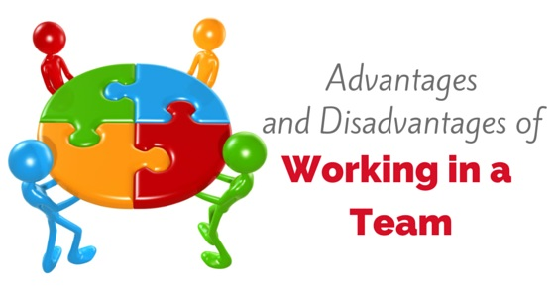
DISCUSS THE IMPORTANCE OF TEAMWORK
- It enables the team to create synergy; in order for the business to combined the efforts from various team members.
- It assists the business to promote creativity to find/combine more solutions to various business complex problems.
- Teamwork create quality of work performance en enables team members to be committed to perform
- The business have the opportunity to increase productivity to let various tasks be completed in given time.
- It increases all levels of motivation and enable team members to keep one another motivated
- It creates participation or involvement in all activities for all team members and therefor increases the opportunity for team members to participate in decision making.

STAGES OF TEAM DEVELOPMENT
STAGE | EXPLANATION
STAGE 1  Forming:  (Getting to know each other) | - Team members voluntarily to work together.  - Team is formed to solve a problem.  - Each team member is driven by the desire to be accepted by the other team members.  - Team members gather info about each other or the objectives of the team.
STAGE 2  Storming:  (True character comes to the fore, perhaps with first round of conflict) | - After the team has been formed, it goes through a period of uneasiness or discomfort known as storming.  - Different ideas are suggested for consideration.  - Team members open up to each other and confront each other’s ideas.  - This stage is necessary for the growth of the team.  - Team members have to be tolerant of and patient with each other to survive this stage.
STAGE 3  Norming:  (Settling in) | - Team members agree on a mutual plan for the team.  - Team members consider their own ideas, but agree with others to make the team perform well.  - Team members address difference of opinions and conflicts are resolved.  - There is evident trust and motivation in the team.
STAGE 4  Performing:  (Working as a team towards a common goal) | - Team members know each other and the team can function as a unit.  - Ways are found to get the job done smoothly without conflict.  - Processes and structures are established.  - The decision making process is handled in the team.  - Make the most of necessary decisions to work towards a common goal.
STAGE 5  Adjourning:  (Mourning period) | - The focus is on the completion of the task.  - Breaking up or adjourning the team may be traumatic as team members may find it difficult to return to a stage performing as individuals.

THEORIES IN TEAM DYNAMICS

Team dynamics are the interactions that occur between people working in a team.

DISCUSS THE REASONS WHY BUSINESSES SHOULD USE TEAM DYNAMIC THEORIES
- It is to determine what makes a team successful or not.
- These theories help to indicate the different roles that team members play in the team and how effective they fulfil the roles.
- Each theory helps the different team members to learn more about the different personalities in a team.
- Team dynamic theories ensure that balanced teams can be formed to ensure all the different roles are covered to get the best possible results.
- Team dynamics is important because it indicates the process of change and growth that will influence the relationships within a team.

PROBLEM SOLVING IN A TEAM

1. Identify the problem
2. Define the problem
3. Formulate the strategy
4. Decide to implement the strategy
5. Allocate resources
6. Monitor the solving of the problem
7. Evaluate to what extent the problem is solved

CONFLICT MANAGEMENT

DEFINE THE FOLLOWING CONCEPTS RELATED TO CONFLICT MANAGEMENT:
CONFLICT- is a state of struggle/ disagreement over opinions/ ideas in the workplace.

Three types of conflict

Intrapersonal conflict- is conflict within one person.

Interpersonal conflict- is conflict between 2 or more people.

Intergroup conflict- is conflict between 2 or more groups.
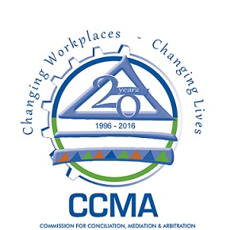

Dispute institutions:
- CCMA
- Labour Court
- Labour Appeal Court

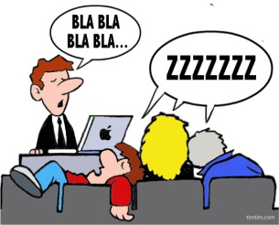
Possible causes of conflict within a team:
Different personalities:
- Conflict is inevitable when people from different backgrounds/ cultures/ values/ races/ gender have to work together in the same environment.
- Different personality types within a team can cause conflict because some employees may be introverts while others are extroverts resulting in different perceptions.

Poor communication:
- Poor communication can lead to all types of misunderstanding and can become very destructive.
- If employees or management decide to sidestep each other’s opinions, team members may become unhappy.

Competition:

- Although competition may be a good motivator, it can become negative if the focus is on competition only and team members lose their team spirit.
- Unhealthy workplace competition may spark conflict as it demoralises employees who cannot always meet targets.

Ignoring rules or procedures:
- Employees who do not follow the rules or procedures can cause conflict as tasks may not be performed according to the business’s specifications.
- Team members who ignore rules or procedures may delay the completion of tasks.

Poor systems and procedures:
- Poor systems and procedures cause stress to workers and make them frustrated.
- If there are not enough guidelines for team members, they will be unorganised in their work.

Workload and stress/ unrealistic expectations:
- When employees are overloaded with work, they become stressed or burnt-out.
- Unrealistic deadlines and heavy workloads lead to stress that can cause conflict.

Confusion about scheduling and deadlines:
- Individual team schedules and deadlines that are not clearly communicated can cause conflict.
- It can be a challenge to reach deadlines.

Unclear responsibilities:

- Employees who are not clear about their responsibilities are more likely to avoid duties and blame others for work not done.

Distracted by personal objectives:
- Some employees may pursue their own personal objectives and they could perhaps try to force their own desires onto the team.

Insufficient resources:
- Team members may fight over the limited resources available to accomplish their/ the team’s tasks.

Constant change:
- Constant change in a business may cause a lack of clarity regarding the roles and responsibilities of each team member.

Conflict resolution process/ procedure:
- Identify and acknowledge that there is conflict.

- Analyse the cause of conflict.

- Arrange a meeting between conflicting team members.

- Arrange a time and place for discussions where all members are present.

- Give each member the opportunity to express his/her own opinions/ feelings.

- Conflicting members may recognize that their views are different.

- Brainstorm possible ways of resolving the conflict.

- Conflicting members agree on criteria to evaluate the suggested and alternative solutions.

- Select and implement the best possible solution.

- Evaluate the implementation of the solution(s).

- Monitor progress to ensure that the conflict has been resolved effectively.

EXPLAIN THE DIFFERENCE BETWEEN TRADE UNIONS AND WORKPLACE FORMS
TRADE UNIONS | WORKPLACE FORUMS
Is an employee organization that focuses on improving working conditions, like COSATU an Solidarity | Is committees of employees who meet with employers to discuss workplace issues.

