SUMMARY: THE NATIONAL BUDGET
1. What is a National Budget?
A national budget is the government’s financial plan for one year (a fiscal year).
It shows:
- How much money the government expects to receive, and
- How it plans to spend that money.
The budget helps the government run the country, provide services, and meet people’s needs.

2. Who Plans the National Budget?
- The Minister of Finance prepares the national budget.
- It is then presented to the National Assembly for approval.

3. Where Does the Money Come From? (Revenue)
The government receives money from:
- Taxes (main source).
- Non-tax revenues, such as mineral royalties and income from state-owned companies.
Two types of taxes:
- Direct taxes – paid directly by people or businesses.
Examples: income tax, corporate tax, capital gains tax, estate duty, skills levies.
- Indirect taxes – paid when buying goods or services.
Examples: VAT, excise duty, customs duty, road accident fund levy, carbon tax.

4. Where Does the Money Go? (Expenditure)
Government uses the budget to fund:
- Education (schools, teachers, curriculum).
- Health (hospitals, clinics, healthcare programmes).
- Housing (RDP houses, rental schemes).
- Social grants (child grants, disability grants).
- Transport (roads, buses, trains).
- Security (police, defence force).
- Economic development (job creation, small business support).
- Environmental protection (conservation, pollution control).
A portion is also used to repay government debt.

5. Key Definitions
- National budget – the government’s yearly financial plan.
- Fiscal year – a 12-month financial period for budgeting.
- Revenues – income the government receives.
- Expenditures – money the government spends.
- Socio-economic development – improving people’s living conditions and growing the economy.

6. Why the National Budget Matters
The budget helps:
- Reduce poverty through social grants and housing.
- Improve education and healthcare.
- Create jobs through infrastructure projects.
- Support small businesses and economic growth.
- Reduce inequality through land reform and development programmes.

7. Challenges
The government faces problems such as:
- Corruption
- Limited resources
- Inefficiency and overspending
These challenges can make it harder for budget plans to succeed.

8. In Short
- The national budget shows where money comes from and how it is spent.
- It supports services like education, health, transport, and housing.
- It helps grow the economy and improve people’s lives.
- Good management is important to prevent waste and misuse of funds.

Name: ​ ​ Date: ​
​
South Africa's National Budget
​
Understanding the Basics 🇿🇦​
​
Just like a household needs a plan to pay for food, rent, and electricity, a country needs a plan for its money. In South Africa, this financial plan is called the National Budget. It details exactly how much money the government expects to collect (Revenue) and how it plans to spend it (Expenditure) over the coming year.

The person in charge of drawing up this important document is the Minister of Finance.
​
Word Bank: Minister of Finance, Revenue, Expenditure, National Budget

 | Definition | Word
1. | The government official responsible for creating the country's financial plan.
2. | The total amount of money the government collects (income).
3. | The document detailing expected income and spending for the year.
4. | Money spent by the government on things like roads and schools.
​
Revenue: Where Does the Money Come From? 💰​

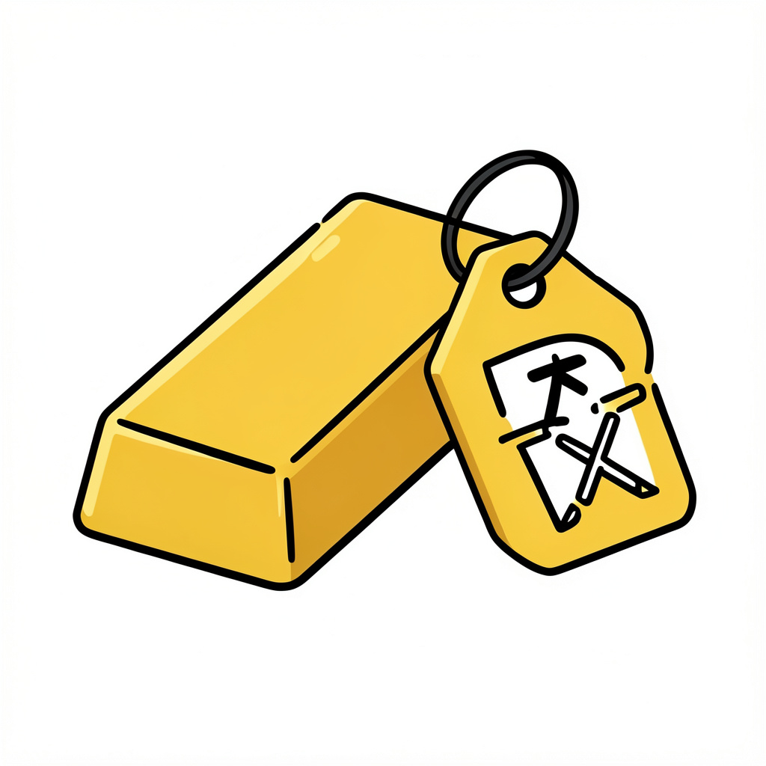
  🧠​ | Direct vs. Indirect Taxes  - Direct Tax: Paid directly to the government from your earnings (e.g., Income Tax).  - Indirect Tax: Added to the price of goods you buy (e.g., VAT on a t-shirt).

1. | Which of the following is an example of an INDIRECT tax? | a) Money taken out of a paycheck (Income Tax)  b) Corporate tax paid by a large business  c) Value-Added Tax (VAT) paid when buying clothes  d) Capital Gains Tax
2. | Besides taxes, how else does the South African government earn money? | a) Donations from other countries  b) Mineral Royalties (money from mining gold or diamonds)  c) Printing more money whenever they need it  d) Selling all public schools to private companies
​
Expenditure: Fixing the Past 🏗️​
​
A major goal of the South African budget is to address inequalities from the past. The government uses the budget to redistribute wealth and ensure everyone has access to basic rights.
​
Word Bank: redistribution, poverty, grants, jobs, infrastructure

South Africa's budget tackles past unfairness through _____________________________. One main way they do this is through social ______________, which provide financial aid to vulnerable groups like the elderly and children to combat _____________.

The government also spends heavily on ______________________ projects, like building roads and hospitals. These projects improve the country and help create _______ for citizens.
​

Reviewing Your Knowledge: The National Budget 📝​
​
Now that we have explored how South Africa's government collects and spends money, let's test your understanding of the key concepts. Read each question carefully and select the best answer.

1. | Which government body is responsible for approving the national budget once it has been created? | a) The High Court  b) The National Assembly  c) The private banks  d) The local police
2. | What are 'Mineral Royalties' in the context of government revenue? | a) Taxes paid by people buying jewelry  b) A direct tax on personal income  c) Money paid to the government for extracting natural resources like gold  d) Donations from foreign mining companies
3. | Which area of expenditure focuses on providing financial aid to vulnerable groups such as children and the elderly? | a) Security  b) Social Grants  c) Economic Development  d) Infrastructure
4. | What is the primary purpose of the national budget? | a) To decide which businesses are allowed to open  b) To track the personal spending of the President  c) To plan the country's expected income and spending for the year  d) To eliminate the need for taxes entirely
​

You are the Minister of Finance 🏛️​

The Decision is Yours  Imagine you have been appointed the Minister of Finance. You have a limited amount of money and must choose ONE priority area to receive the biggest increase in funding this year.  Choose one from the list below:  - Education (Schools, universities, teachers)  - Healthcare (Hospitals, clinics, medicine)  - Infrastructure (Roads, bridges, public transport) | 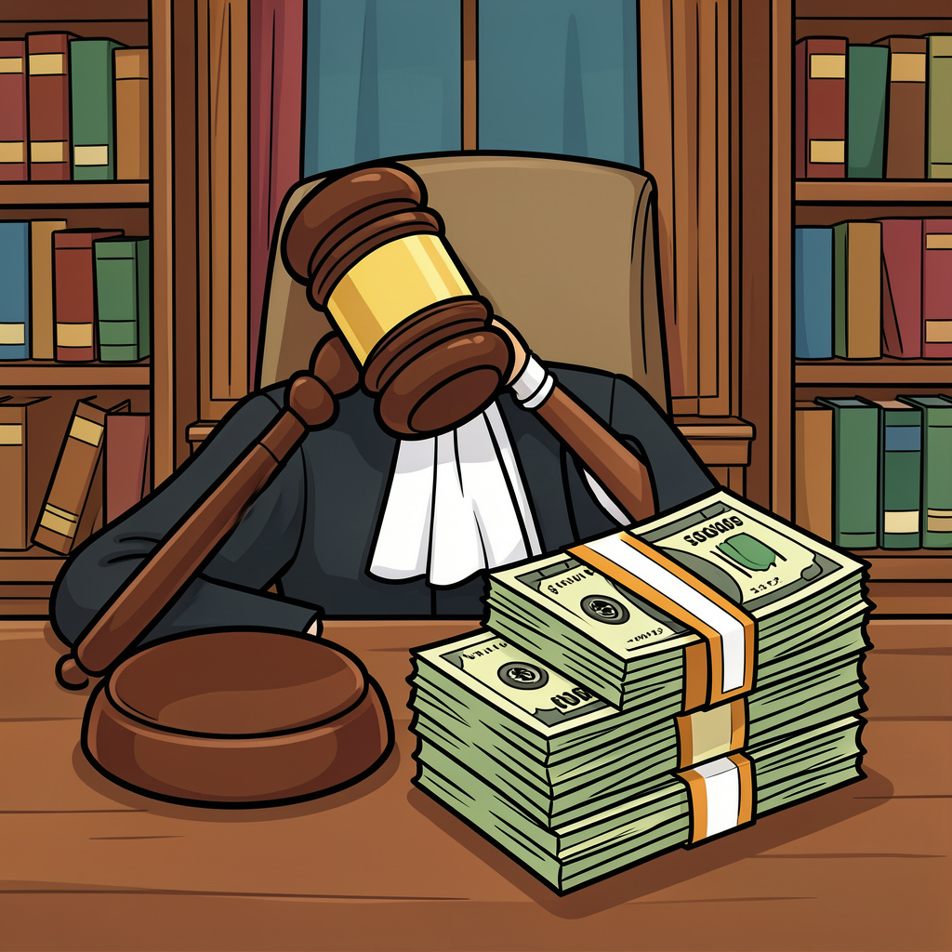
​
Which area did you choose and why? Explain how your choice would help the country's future.

Answer Key
​
Understanding the Basics 🇿🇦​
​
Vocabulary Practice:
1. Minister of Finance
2. Revenue
3. National Budget
4. Expenditure
​
Revenue: Where Does the Money Come From? 💰​
​
Multiple Choice:
1. Value-Added Tax (VAT) paid when buying clothes
2. Mineral Royalties (money from mining gold or diamonds)
​
Expenditure: Fixing the Past 🏗️​
​
Cloze:
South Africa's budget tackles past unfairness through redistribution. One main way they do this is through social grants, which provide financial aid to vulnerable groups like the elderly and children to combat poverty.

The government also spends heavily on infrastructure projects, like building roads and hospitals. These projects improve the country and help create jobs for citizens.
​
Reviewing Your Knowledge: The National Budget 📝​
​
Multiple Choice:
1. The National Assembly is the legislative body that must approve the budget created by the Minister of Finance.
2. Mineral Royalties are a form of non-tax revenue paid for the right to mine minerals like gold or diamonds.
3. Social Grants are specifically designed to provide financial support to vulnerable citizens to combat poverty.
4. The national budget is a financial plan that details expected revenues and expenditures for a fiscal year.
​
You are the Minister of Finance 🏛️​
​
Answer:
Answers will vary. Example: I would choose Education because learning builds the future. If people are educated, they can get better jobs, which helps the whole economy grow.

