SUMMARY: TOPIC 1 – THE NATIONAL GOVERNMENT
1. Introduction
A government is a group of people who make and enforce laws to guide a country or community.
There are different types of government:
- Democracy – citizens vote and have a say.
- Monarchy – a king or queen rules for life.
- Dictatorship – one person or group has complete control.
- Autocracy – one person makes decisions alone.
2. Functions of Government
Governments:
- Make and enforce laws.
- Maintain law and order and settle disputes.
- Protect citizens’ rights.
- Provide services like healthcare and education.
- Regulate the economy and environment.
LEVELS OF GOVERNMENT IN SOUTH Africa
a) Three Levels: National, Provincial & Local
- National Government – highest level; deals with issues affecting the whole country.
- Provincial Government – manages matters specific to each province.
- Local Government – handles services in municipalities (e.g., waste removal, street lights).
National Government
- Led by the President.
- Parliament includes:
  - National Assembly – makes laws and ensures accountability.
  - National Council of Provinces – represents provinces’ interests.
Provincial Government
- Led by a Premier and a provincial legislature.
- Makes provincial laws and implements policies.
Local Government
- Consists of metropolitan, district, and local municipalities.
- Councils pass local laws and deliver basic services.
b) The Three Arms of Government
- Legislative Branch – makes laws (Parliament).
- Executive Branch – enforces laws (President and Cabinet).
- Judicial Branch – interprets laws and settles disputes (courts).

c) Overall Summary
South Africa has:
- Three levels of government (national, provincial, local), each with specific responsibilities.
- Three branches of government (legislative, executive, judicial) that work together to run the country effectively.

ROLES OF GOVERNMENT IN THE USE OF RESOURCES AND SERVICES
Section 1: Government and Households
1.1 Consumers and Producers
- Consumers buy or use goods and services.
- Producers create and supply goods and services.

1.2 Government as a Customer of Households
Government buys goods and services from households, for example:
- Hiring teachers, doctors, and nurses.
- Building roads and bridges.
- Providing grants and social support.
Purpose: create jobs and support the economy.

1.3 Government as a Producer for Households
Government provides services to households, such as:
- Education, healthcare, and infrastructure.
- Regulating the economy and protecting the environment.
- Issuing permits and licenses.
- Supporting economic development and land reform.
Purpose: ensure safety, access to services, and economic growth.

Section 2: Government and Businesses
2.1 Government as a Customer of Businesses
Government buys goods and services from companies, such as:
- Office supplies and consulting services.
- Infrastructure and construction projects.
- Defence contracts.
Purpose: stimulate business growth and job creation.

2.2 Government as a Producer for Businesses
Government provides services that help businesses operate:
- Transport infrastructure.
- Labour, environmental, and consumer protection regulations.
- Issuing business licenses.
- Economic development programmes.
- Tax policies that lower costs.

Purpose: create a fair, safe, and supportive environment for businesses to grow.

Name: ​ ​ Date: ​
​
The National Government: End-of-Topic Test
​
Instructions

📢​ | Time Allowed: 40 minutes  Instructions:  - Answer ALL questions.  - Write your answers in the spaces provided.  - This test covers types of government, branches and levels of government, and the economic role of government (based on the unit resources).
​
Section A: Types of Government

For questions 1–3, select the correct definition for each type of government.
​
1. A system where people have a say in how the government is run, usually through voting.

a) Autocracy | b) Democracy | c) Monarchy | d) Dictatorship
​
2. A system where a king or queen holds power for life.

a) Autocracy | b) Democracy | c) Monarchy | d) Dictatorship
​
3. A system ruled by a single person or group with complete control, often without input from others.

a) Republic | b) Democracy | c) Federation | d) Dictatorship

​

4. Explain the primary difference between a Dictatorship and a Democracy in your own words.
​
Section B: Branches of Government
​
The government is divided into three branches to ensure power is shared. Study the diagram below and answer the questions.
​
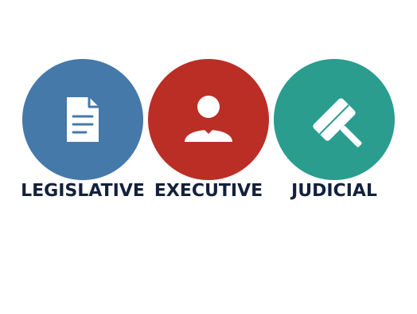​
5. Match the branch to its correct function by drawing a line or writing the letter in the box.

Branch | Ans | Function
Legislative Branch |  | A. Interprets laws and settles disputes
Executive Branch |  | B. Makes the laws (Parliament)
Judicial Branch |  | C. Enforces laws and runs the government
​

6. Who leads the Executive Branch?

​Section C: Levels of Government

Government responsibilities are divided into three levels: National, Provincial, and Local.  ​  7. Which level of government is responsible for issues specific to a province?  ​  8. List two services provided by Local Government (Municipalities). | 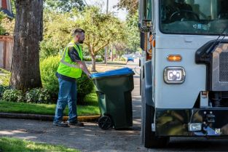
​
Section D: Government and the Economy
​
Governments act as both consumers (buying things) and producers (making/providing things) for households and businesses.
9. Read each scenario below and check (✓​) whether the government is acting as a Consumer or a Producer.
Scenario | Consumer | Producer
The government hires a construction company to build a new bridge.
The government provides free education at public schools.
The government buys office supplies from a local stationery business.
The government issues a fishing license to a business.
​
10. Using the image below for context, explain how the government supports the economy by building infrastructure.

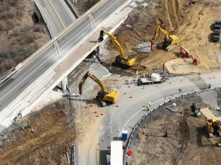
​
Section E: Extended Response
​
11. Why is it important for the government to be separated into three different branches (Legislative, Executive, Judicial) rather than having one person do everything? Use the term 'power' in your answer.

Answer Key
​
Section A: Types of Government
​
b) Democracy
​
c) Monarchy
​
d) Dictatorship
​
Answer:
In a democracy, citizens vote and have a say; in a dictatorship, one person/group has total control with no input from people.
​
Section B: Branches of Government
​
Legislative-B, Executive-C, Judicial-A
​
Answer:
The President and the Cabinet
​
Section C: Levels of Government
​
Answer:
Provincial Government
​
Answer:
Garbage collection, street lighting, water/electricity distribution
​
Section D: Government and the Economy
​
- Consumer, 2. Producer, 3. Consumer, 4. Producer
​
Answer:
It creates jobs during construction (hiring workers), and helps businesses transport goods more easily afterwards.
​
Section E: Extended Response
​
Answer:
Separating branches prevents one person or group from having too much power. It ensures a system of checks and balances where laws are made, enforced, and interpreted by different people to ensure fairness and justice.

