ANSWERS
- Expansion is characterised by growth in real GDP and income. 
Consists of two phases – recovery and prosperity (also called the
boom).  (4)
 
- Contraction is a period of gradual decline in economic activity. 
There is a decrease in aggregate demand that forces a decrease in output.  (4)
3.
  - JSE all share index
  - Money supply (M1)
  - Consumer price index
  - Factory hours worked opinion survey
  - Business cycle indicators of our major
  - trading partners
  - Manufacturing orders opinion survey
  - Inventory versus demand opinion survey (any 3 X 1)(3)

4.
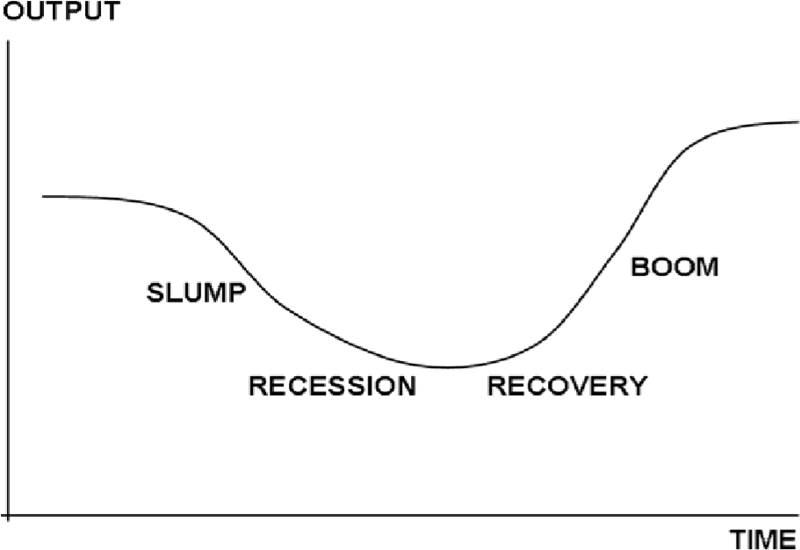 (4)

Contraction phase  is the downward phase of the business cycle. During this phase spending declines, gross domestic product falls, employment decreases, business confidence declines and income falls. 
Trough  is the point where the economic contraction is at its lowest. It is followed by an expansion.  
Expansion phase occurs when economic activity rises. This is reflected in an increase in spending, gross domestic product and employment.  
Peak is the point where the economic expansion is at its highest, after which it is followed by a contraction.
( 4 for diagram and 4 for note) (8)

5.
Variable | Contraction phase
a) Gross domestic product | Decrease
b) Level of economic activity | Decrease
c) Total spending | Decrease
d) Level of production | Decrease
e) Consumer spending | Decrease
f) Investment confidence | Decrease
g) Investment spending | Decrease
h) Imports | Decrease
i) Inflation | Decrease
(9)
- During the upswing imports increase which negatively affects the balance of payments and leads to a depreciation of the exchange rate and an increase in the interest rate. These factors then impact negatively on the economy and a slow-down occurs. Or it might be that the increase in total spending leads to an increase in inflation, which negatively impacts on the level of economic activity. (8)

- Exogenous factors are factors that have nothing to do with the business cycle such as
natural disasters or droughts. 
It is not possible to control these factors. 
Endogenous factors are factors within the business cycle such as changes in interest rates or changes in aggregate demand. 
These factors can be controlled to a certain degree.  (8)

