
SOURCE DOCUMENTS

A transaction is an exchange of goods, services, or money between two parties. For example, if a store sells a toy to a customer, this is a transaction. The customer gives the store money in exchange for the toy. A source document is a record that provides evidence of a transaction. It is important because it helps keep track of all the transactions that a business does.

Here are some common source documents used in business:

Receipt: This is a document that is given to a customer when they buy something. It shows what they bought, how much it cost, and the date of the purchase.

Bank Statement This is a document that a bank sends to a business, which shows all the transactions that have been made through the business's bank account.

Proof of Payment This is a document that proves that a payment has been made over the internet. We can also call the transaction an ELECTRONIC FUNDS TRANSFER (EFT).

Cash Invoice This is an invoice that is paid for in cash. It shows what was bought, how much it cost, and the date of the purchase.

Cash Register Tape This is a record of all the transactions that have been made using a cash register. It shows the items that were bought, the prices, and the total amount of the sale.

SOURCE DOCUMENTS FOR MONEY RECEIVED BY THE BUSINESS:

- RECEIPT


RECEIPT

Peter Ndlovu Repairs
 | No. 345
 | Date: 06 February 2023
 | Received from: Peter Ndlovu____________
 | For: Capital Contribution________________
 | The amount of: Hundred thousand rand |  |  |  | R100 000 - 00
 | ______________ nil cent |  |  |  | R100 000 - 00
 | Cash | Card
 | P Ntuli
 | Peter Ndlovo Repairs

Explanation of the information on the receipt
Document name
The name of the business
The receipt of the number
The date what the transaction took place
The person that paid the money or from whom it was received
What the money was received for (capital, commission or rent)
The amount received in WORDS
The amount received in FIGURES
How was the money received? Cash of debit or credit card.
The person that received the money at the business

- CASH REGISTER SLIP

Slip 3 |  | Slip number
07/02/2023 |  | Date of transaction
Cash register 3 |  | Cash register (till) number
Coffee | R89,50 | What was bought
Sugar | R37,60 | #Product with no VAT charged on it
Appels | R15,50# | Cost of the different products
Sardines | R14,40#
TOTAL | R157,00 | Total cost of transaction, amount paid by clients and the change, amount paid towards VAT
Cash | R160,00
Change | R3,00
15% VAT | R20,48
SLIP 098 |  | Slip number
VAT no. 876 568 907 |  | VAT number of business – implies that business is registered for VAT
Thank you

- BANK DEPOSIT SLIP

  - A Deposit Slip is filled out what notes, coins are deposited in a bank account or.
  - The money and deposit slip are handed to the teller together.
  - A Duplicate Slip with a stamp from the bank is given to the person who deposits the money.
  - This is a very expensive way of depositing money because cash handling fees get charged. This expense is part of BANK CHARGES.
  - Every banks’ bank deposit slip looks different and the teller at the bank completes most of slip for you. All you have to complete is the bank account where the money will be deposited in.

Here are an example:
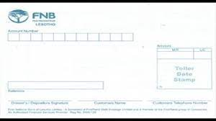
At FNB you have to
complete the
bank account number,
and sign.
The rest of the information will be completed by the teller.

- Alternatively you can deposit the money at am ATM machine. You will complete all the information electronically.
- After the money was successfully deposited the bank will give you an option to receive an e-mail to confirm the transaction (see next page).
- After that, they will give you a bank slip as confirmation.

Name of document
Time of transaction
Date of transaction
Costumer in whose account the money is paid in
Account number
0987654
Amount paid into account
Reference for person receiving the money
Bank stamp
Information on the bank stamp includes the branch number, date of transaction and the ATM where the money was paid in. This is the surety that the transaction is legit and authentic.

Bank stamp
Transaction information
Bank information

- Cash invoice
Sometimes it happens that a business issues a CASH INVOICE (tax invoice) for you before you do or receive the EFT.

231 Sisulu Avenue  Port Elizabeth  Tel: 041 652 9341 |  | VAT number: 627613667 | PO Box 8967  Port Elizabeth  6020  Fax: 041 6529355
Date: 2010/06/15 | Tax invoice |  | No.0177
Too:  Middleburg Building Shop  4th Avenue  Summerstrand |  |  | Method of payment
 |  |  | Debit card |  | X
 |  |  | Cash
 |  |  | Credit card
 |  |  | On account
Code | Description | Amount | Price | Total price
G431 | Carpet | 20 | R56/m | 1030.00
G652 | Floor tiles | 14 | R35/m | R490.00
Sub total |  |  |  | 1 520.00
VAT @ 15% |  |  |  | 228,00
Total |  |  |  | R1 748,00
Amount |  |  |  | -
F & A excluded Change |  |  |  | -

Explanation:
Street address of business that issued cash invoice / tax invoice.
VAT number (if registered for VAT)
Postal address of business that issued the cash or tax invoice.
Date of transaction
Cash or tax invoice number
Address of business that is buying goods.
Method of payment (see additional notes)
Information of transaction – what they bought, for how much, VAT etc.
Faults and admissions excluded – to indemnify the business against errors on the invoice.

SOURCE DOCUMENTS FOR MONEY PAID BY THE BUSINESS:

- PROOF OF PAYMENT

There are many different ways that we business can pay their accounts.
EFT: An Electronic Funds Transfer is the electronic transfer of money over an online network. This can be done between the same bank or another one.

Debit card: A debit card is a payment card that deducts money directly from a customer's current account for purchases. It can also be used to withdraw money from an ATM.

Credit card: A credit card is a payment card where the client incurs debt with the bank. The business treats it as a cash transaction.

Cash: Money is paid into the business in the form of notes and coins and money is received immediately
There must be proof that the transaction took place. A proof of payment can come in different forms. If you paid cash, you will receive a RECEIPT. When you pay with a debit or credit card, you will receive a slip, that looks like this:
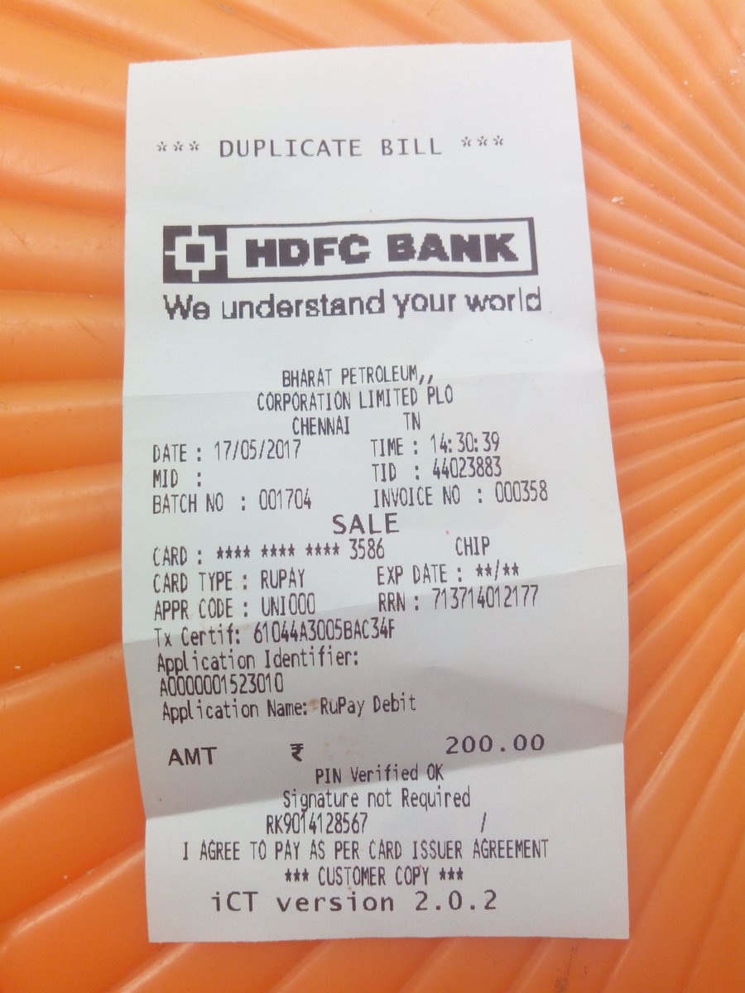
When you make an internet transfer or an electronic funds transfer (EFT), you normally will receive a e-mail, with a PDF document, that you can use as proof of payment (see page 24).

All transactions are only truly paid, once it can be seen on your BANK STATEMENT.

- Bank statement
A printed record of the balance of the bank account and the amounts paid into it or withdrawn from it.
Information:
Sam Dlamini started his own motor repair shop with a capital contribution on 16 March 2020. He used most of her capital to equipment for Sam’s Repairs. Mr Dlamini receives the following bank statement from FNB.
BANK STATEMENT
Sam’s Repairs  Shop 231  Turflaagte  Bloemfontein, 9301  Period: 16 March to 31 March 2020  Account number: 62 098 876 765  Current account |  | 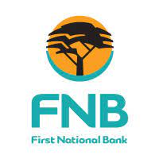  FNB  Maitland Branch  Charlotte Maxeke Street 20  Bloemfontein  9301  31 March 2020
Date | Transactions description | Debit | Credit | Balance
16 | Deposit – Sam Dlamini |  | 50 000.00 | 50 000.00Cr
20 | EFT Payments 01 - Supreme Motors | 37 000 |  | 13 000.00Cr
 | Stop order – insurance | 750.00 |  | 12 250.00Cr
21 | EFT payment 02 – AB stationery | 500.00 |  | 11 750.00Cr
23 | Internet transfer – B. Mosa rent |  | 1 100.00 | 12 850.00Cr
 | Stop order – Rent payment | 2 700.00 |  | 9 150.00Cr
24 | Cash deposit |  | 7 000.00 | 16 150.00Cr
 | Cash handling fees | 45.00 |  | 16 105.00Cr
 | Electronic transfer: J. Dube (Salary) | 2 800.00 |  | 13 305.00Cr
30 | Interest on credit balance |  | 399,15 | 13 704,15Cr
 | Service fees | 140.00 |  | 13 704.15Cr
 | Month closing balance |  |  | 13 704.15Cr

EXPLANATION:
Name of source document
Name and address of business
Name and address of bank
Period that the statement was printed for
Account number
Type of business (in this case the current account, but it can also be a saving account or business account)
The day the statement was printed
Days those transactions took place on
Description of transaction (Gives information on what type of transaction was paid and by who)
Money that is paid out of the bank account – DECREASES account
Money that is paid into the bank account – INCREASES account
Money that is in the bank account

EXPLANATION OF TRANSACTIONS:
Date | Transaction description | Explanation
15 | Deposito – Sam Dlamini | Deposit by the owner – thus capital, makes account balance more
20 | EFT payment 01 – Supreme Repairs | EFT payment in favour Supreme Repairs (bought equipment) – decrease account balance
 | Stop order – insurance | Stop order for insurance decrease account balance
21 | EFT payment 02 – AB Stationery | EFT payment to AB Stationery (bought stationery) – decreases account
23 | Internet transfer – B. Mosa rent | Receive money from B Mosa for rent, increase account
 | Stop order – Rent payment | Stop order, that decreases account for rent expense
24 | Cash deposit | Cash money that is paid by the business into the bank account, normally for services rendered, increases bank account
 | Cash handling fees | Bank of bank charges, decrease bank account
 | Electronic transfer: J. Dube (Salary) | Paid J Dube’s salary, decreases bank account
30 | Interest on credit balance | Interest on current account, increase bank account
 | Service fees | Part of bank charges, decreases bank account
 | Month closing balance | Balance of the bank account at the end of the month

SOURCE DOCUMENTS – ACTIVITIES
ACTIVITY 1: Source documents

Look at the receipt given and answer the questions:

RECEIPT

Sarah Rentals
 | No. 897
 | Date: 07 February 2023
 | Received from: Samantha Buang____________
 | For: Rent income_______________
 | The amount of: Fifteen thousand__ rand |  |  |  | R15 000 - 00
 | ______________ nil cent |  |  |  | R15 000 - 00
 | Cash | Card
 | S Mokoena
 | Sarah Rentals

- When is a receipt issued?
- When was this receipt issued?
- To whom was the receipt issued?
- What was the receipt issued for and for what amount?
- Did the costumer pay cash or card? Why would that information be important?
- If you pay someone in cash or with a card, why would you want a receipt?
- Who is the person and business that issued the receipt?

ACTIVITY 2: Source documents

Look at the cash register slip given and answer the questions:

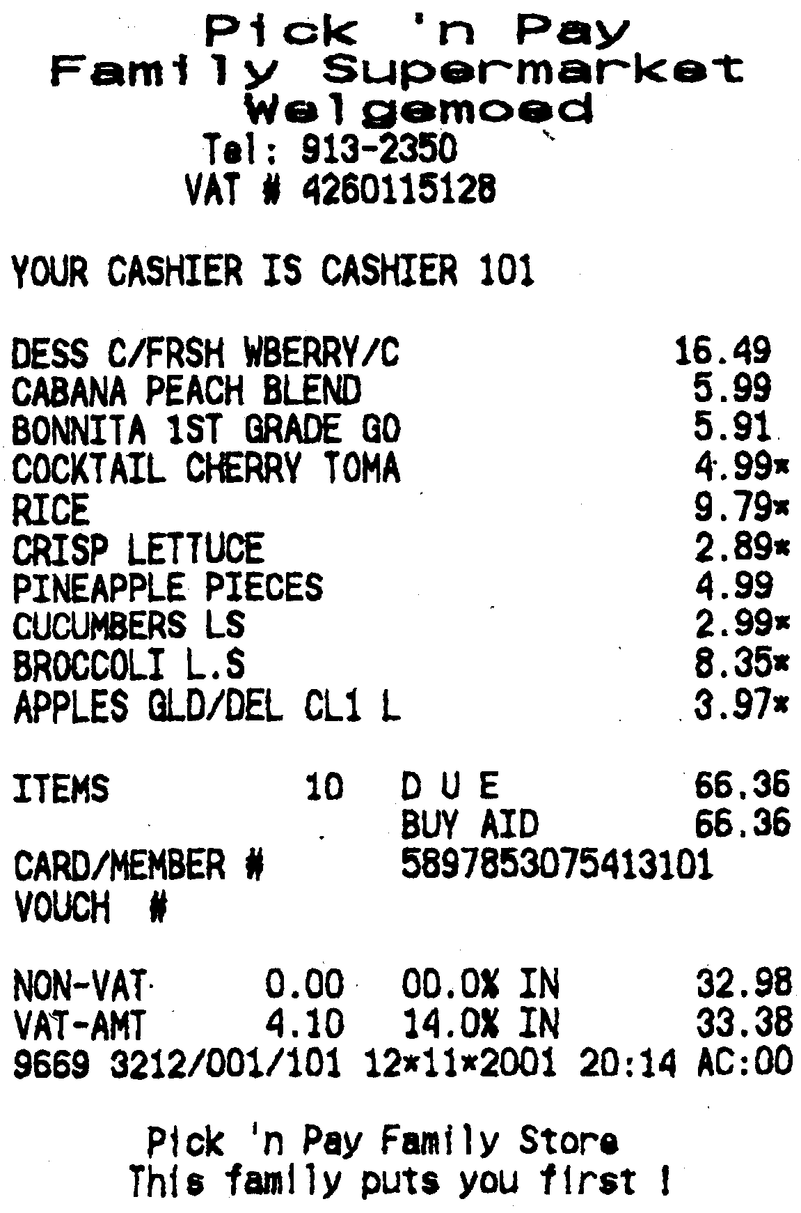
Questions:
a) At what shop did this transaction take place?
b) What was the cashiers name?
c) On what day and time did this transaction take place?
d) What does the * at certain amounts mean? Why does the government do that?
e) What was the total amount of items bought and the total price?
f) Is this business registered for VAT? Give a reason for your answer.

ACTIVITY 3: Source documents
Look at the following cash deposit slip and identify:
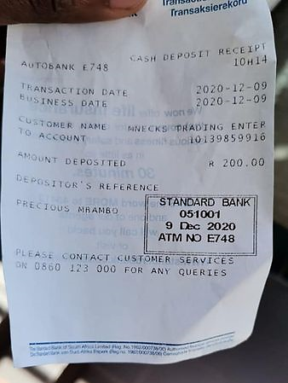
Questions:
a) The time of the transaction
b) The date of the transaction
c) Account holder in whose account the money was paid into
d) The account number
e) The amount deposited
f) The reference
g) The information on the bank stamp.
h) Why is the bank stamp important?

ACTIVITY 31: Source documents
Answer the questions after investigating the bank statement received.

Dora Mendes started her own exploring business with a capital contribution on April 15, 2021. She used most of her capital to buy equipment vehicles etc for her business. Dora receives the following bank statement in the post and asked you to help her understand it.

BANK STATEMENT
Dora Explora  18 Tenth Street  Dewetsdorp, 1981  Period: 15 April 2021 to 30 April 2021  Account no: 6211163145 Current account |  |   Explorer Bank  18 Nelson Mandela Road  Johannesburg  1001  30 April 2021
Date | Transaction description | Debit | Credit | Balance
15 | Deposit |  | 25 000.00 | 25 000Cr
20 | EFT payment 01 | 18 500.00 |  | 6 500Cr
 | Stop order – Insurance | 687.20 |  | 5 812.80Cr
21 | EFT payment 02 | 480.80 |  | 5 332.00Cr
23 | Internet transfer – B. Baloyi |  | 250.00 | 5 582.00Cr
 | Stop order – Rent payment | 1 350.00 |  | 4 232.00Cr
24 | Cash deposit |  | 3 750.00 | 7 982.00Cr
 | Cash handling fees | 37.50 |  | 7 944.50Cr
 | Electronic transfer: J. Monso Salary) | 2 472.08 |  | 5 472.42Cr
30 | Interest on Credit balance |  | 15.70 | 5 488.12Cr
 | Service Fees | 120.50 |  | 5 367.62Cr
 | Month – closing balance |  |  | 5 367.62Cr

Questions:
    - What is the name of Dora’s business?
    - At what bank does Dora have a bank account?
    - What type of bank account did Dora open and when did she open it?
    - Give the physical address of Dora’s business.
    - What was the amount of Dora's Capital Contribution
    - What was the initial cost of the equipment Dora bought?
    - How many people work in Dora’s business and what are they paid?
    - Why did Dora receive interest?
    - How much did Dora pay in rent this month?
    - What is the month-end balance on the account?
    - In which column on the bank statement are the deposits shown?
    - How much did Dora have to pay the bank for Service Fees?
    - What is the accounting term for the service fees charged by the bank?

SOURCE DOCUMENTS – MARKING GUIDELINE

ACTIVITY 1: Source documents

Look at the receipt given and answer the questions:

RECEIPT

Sarah Rentals
 | No. 897
 | Date: 07 February 2023
 | Received from: Samantha Buang____________
 | For: Rent income_______________
 | The amount of: Fifteen thousand__ rand |  |  |  | R15 000 - 00
 | ______________ nil cent |  |  |  | R15 000 - 00
 | Cash | Card
 | S Mokoena
 | Sarah Rentals

- When is a receipt issued? When money is received at a business to serve as proof of the transaction
- When was this receipt issued? 7 February 2023
- To whom was the receipt issued? Samantha Buang.
- What was the receipt issued for and for what amount? Rent income, R15 000
- Did the costumer pay cash or card? Why would that information be important? The costumer paid with a card – so that there can be control over the money received.
- If you pay someone in cash or with a card, why would you want a receipt? The receipt will serve as your proof of the transaction.
- Who is the person and business that issued the receipt? S Mokoena issued the receipt for Sarah Rental

ACTIVITY 2: Source documents

Look at the cash register slip given and answer the questions:

Questions:
a) At what shop did this transaction take place? Pick ’n Pay Family Supermarket Welgemoed
b) What was the cashiers name? Cashier 101
c) On what day and time did this transaction take place? 12/11/2001 at 12:14
d) What does the * at certain amounts mean? Why does the government do that? Items that are VAT exempted (no VAT is charged)
e) What was the total amount of items bought and the total price? 10 items and R66, 36
f) Is this business registered for VAT? Give a reason for your answer. Yes, the business has a VAT number - 4260115128

ACTIVITY 3: Source documents
Look at the following cash deposit slip and identify:

Questions:
a) The time of the transaction: 10:14
b) The date of the transaction: 09-12-2020
c) Account holder in whose account the money was paid into: Mnecks Trading enter
d) The account number: 10139859916
e) The amount deposited: R200,00
f) The reference: Precious Mbambo
g) The information on the bank stamp: Standard bank, branch code, 051001, date- 9 Dec 2020 and the ATM no E748 where the money was deposited
h) Why is the bank stamp important? Ensures that the transaction is authentic and verified by the bank

ACTIVITY 4: Source documents
Answer the questions after investigating the bank statement received.
Dora Mendes started her own exploring business with a capital contribution on April 15, 2021. She used most of her capital to buy equipment vehicles etc for her business. Dora receives the following bank statement in the post and asked you to help her understand it.

BANK STATEMENT
Dora Explora  18 Tenth Street  Dewetsdorp, 1981  Period: 15 April 2021 to 30 April 2021  Account no: 6211163145 Current account |  | Explorer Bank  18 Nelson Mandela Road  Johannesburg  1001  30 April 2021
Date | Transaction description | Debit | Credit | Balance
15 | Deposit |  | 25 000.00 | 25 000Cr
20 | EFT payment 01 | 18 500.00 |  | 6 500Cr
 | Stop order – Insurance | 687.20 |  | 5 812.80Cr
21 | EFT payment 02 | 480.80 |  | 5 332.00Cr
23 | Internet transfer – B. Baloyi |  | 250.00 | 5 582.00Cr
 | Stop order – Rent payment | 1 350.00 |  | 4 232.00Cr
24 | Cash deposit |  | 3 750.00 | 7 982.00Cr
 | Cash handling fees | 37.50 |  | 7 944.50Cr
 | Electronic transfer: J. Monso Salary) | 2 472.08 |  | 5 472.42Cr
30 | Interest on Credit balance |  | 15.70 | 5 488.12Cr
 | Service Fees | 120.50 |  | 5 367.62Cr
 | Month – closing balance |  |  | 5 367.62Cr

Questions:
    - What is the name of Dora’s business? Dora Explora
    - At what bank does Dora have a bank account? Explorer Bank
    - What type of bank account did Dora open and when did she open it? Current account
    - Give the physical address of Dora’s business. 18 Tenth Street, Dewetsdorp 1981
    - What was the amount of Dora's Capital Contribution: R25 000
    - What was the initial cost of the equipment Dora bought? R18 500
    - How many people work in Dora’s business? How do you know that? What are they paid? One, was paid a salary of R2 472,08.
    - Why did Dora receive interest? She has a positive account and the bank is rewarding them for the positive bank account.
    - How much did Dora pay in rent this month? R1 350,00
    - What is the month-end balance on the account? R5 367,62
    - In which column on the bank statement are the deposits shown? In the credit column
    - How much did Dora have to pay the bank for Service Fees? R120,50
    - What is the accounting term for the service fees charged by the bank? Bank charges

