SUMMARY: Standard of Living
1. Lifestyles
A lifestyle refers to the way a person chooses to live, including their work, free time, values, and beliefs. Everyone’s lifestyle is different.
Examples of lifestyles include:
- Workaholic: Focuses heavily on career and income, with little time for leisure or family.
- Family-Centric: Prioritises family time, togetherness, and shared activities.
- Environmentally Conscious: Makes eco-friendly choices such as recycling, reducing waste, and lowering their carbon footprint.
- Student Lifestyle: Balances schoolwork, hobbies, and social life.
Key idea: There is no right or wrong lifestyle—your choices should match your values, and your lifestyle can change over time.

2. Modern Societies
Definition:
Societies with advanced technology, scientific progress, cultural development, urbanisation, and specialised labour.
Characteristics: High industrialisation, large cities, global connections, diversity, and growing individualism.
Advantages: | Disadvantages:
- Better technology and healthcare  - Higher standard of living  - More job and economic opportunities  - Greater freedom and access to education  - Cultural diversity | - Inequality and poverty  - Environmental damage  - Loneliness in urban life  - Overconsumption  - Dependence on technology  - Social issues such as crime and homelessness

3. Rural Societies
Definition:
Communities with farming-based livelihoods, low population density, and traditional ways of life.
Characteristics: Farming, strong community ties, close connection to nature, and a slower, more peaceful lifestyle.
Advantages: | Disadvantages:
- Strong social connections  - Healthy natural environment  - Less stress, more leisure  - Traditional culture and crafts | - Few economic opportunities  - Limited access to services (healthcare, education)  - Isolation and less technology  - Young people often move to cities

4. Impact of Development on the Environment
Development improves living standards but also harms the environment.
In modern societies: Pollution, deforestation, and habitat loss result from industrialisation and urban growth.
In rural societies: Unsustainable farming can cause soil damage and deforestation.
Solutions:
- Use eco-friendly technology
- Promote renewable energy
- Reduce waste and recycle
- Protect wildlife and natural areas
- Increase environmental education

5. Unemployment
Definition:
People aged 16–65 who are without work but actively looking for a job.
In modern societies: Caused by automation and jobs moving overseas.
In rural societies: Caused by limited opportunities and youth migration to cities.
Solutions:
- Education and skills training
- Supporting small businesses
- Encouraging foreign investment
- Government job-creation policies
- Growing local industries
6. Productive Use of Resources for a Healthy Environment
Sustainable resource use helps protect the environment.
Modern societies: Use renewable energy, recycle, and reduce waste.
Rural societies: Apply sustainable farming practices like crop rotation and agroforestry.
Solutions:
- Sustainable agriculture
- Renewable energy
- Wildlife and habitat conservation
- Waste reduction and recycling
- Environmental awareness programmes

Name: ​ ​ Date: ​
​
📊​ Development Indicators Data Analysis
​
Comparative Data Analysis
​
In this activity, you will analyze a dataset comparing three fictional countries. Each country represents a different level of development with unique trade-offs between standard of living (material wealth) and quality of life (health, environment, happiness).

Review the data table below and answer the questions that follow.

Indicator | Country A  (Highly Modernized) | Country B  (Rural / Agrarian) | Country C  (Transitional)
GDP Per Capita  (Average Income) | $62,000 | $3,500 | $12,000
Life Expectancy | 81 years | 64 years | 72 years
Unemployment Rate | 6.5% | 2.1% | 9.8%
Air Quality Index  (Lower is better) | 145 (Unhealthy) | 25 (Good) | 85 (Moderate)
Internet Access  (% of population) | 98% | 15% | 60%
Reported Stress Levels  (Scale 1-10) | 8.2 | 4.5 | 6.0
​

Data Interpretation Questions

1. Based on the GDP Per Capita and Internet Access data, which country has the highest Standard of Living? Explain your choice using the definition from our lesson. | 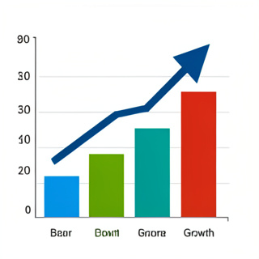
​
2. Compare Country A and Country B. What is the trade-off observed between economic wealth and environmental health (Air Quality)?

​
3. Look at the Unemployment Rate. Surprisingly, the wealthy Country A has higher unemployment (6.5%) than the rural Country B (2.1%). Based on what you know about modern societies, why might this be?

​
Critical Thinking: Quality of Life vs. Standard of Living

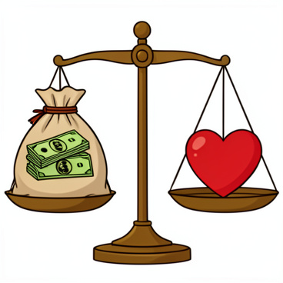 | ​  4. Which country do you believe has the best overall Quality of Life? Use at least two specific data points (e.g., Stress Levels, Life Expectancy, or Air Quality) to support your argument. There is no single correct answer, but you must justify your choice.
  🧠​ | Remember: Standard of living measures wealth and comfort. Quality of life measures health, happiness, and freedom.

​
5. Country C is "Transitional." It has moderate wealth but the highest unemployment rate (9.8%). What challenge of moving from a rural to a modern society might be causing this?

Answer Key
​
Data Interpretation Questions
​
Answer:
Country A. It has the highest income ($62,000) and internet access (98%), which aligns with the definition of standard of living (wealth, material goods, technology).
​
Answer:
Country A has high wealth but poor air quality (145), while Country B has low wealth but very clean air (25). This shows a trade-off where industrialization increases wealth but harms the environment.
​
Answer:
Modern societies often face automation displacing workers or jobs moving internationally (globalization), whereas rural societies often rely on farming where there is always labor to be done, even if low-paying.
​
Critical Thinking: Quality of Life vs. Standard of Living
​
Answer:
Answers will vary. Students might choose Country A for long life expectancy (81) despite stress. Or Country B for low stress (4.5) and clean air (25), despite lower life expectancy. Or Country C as a balance.
​
Answer:
They might be experiencing the shift where traditional farming jobs are disappearing but new tech/industrial jobs haven't fully been created yet, or people lack the skills for new jobs.

