📊 EMS Study Sheet – The 4 Functions of Management (Grade 8)
Managers perform four important functions to help a business run successfully:
Planning → Organising → Leadership → Controlling
Function of Management | Definition | Why it is Important | Main Characteristics / Skills
📋 Planning | Planning means setting goals and deciding how to achieve them. | • Helps managers know what must be done. • Ensures resources and time are used effectively. • Helps the organisation stay focused on its goals. | • Goal-oriented • Forward-thinking • Systematic • Adaptable
🗂 Organising | Organising means arranging resources, tasks and people so that goals can be achieved. | • Ensures resources are used effectively. • Helps divide work between employees. • Improves teamwork and productivity. | • Structured • Efficient • Clear communication • Good coordination
👥 Leadership | Leadership means guiding, motivating and influencing people to achieve organisational goals. | • Encourages teamwork. • Inspires employees to do their best. • Helps create a positive work environment. | • Inspirational • Good communication skills • Supportive • Empathetic
📊 Controlling | Controlling means checking if the work is done according to the plan and correcting mistakes if necessary. | • Ensures goals are achieved. • Helps managers identify problems early. • Allows improvements and adjustments. | • Analytical • Attention to detail • Objective • Adaptable

🔄 How the Functions Work Together
📌 Important:
These functions work together in a continuous cycle to help a business achieve its goals.

Step | What Happens
1. Planning | Managers decide what must be done and how to do it.
2. Organising | Resources, tasks and people are arranged to carry out the plan.
3. Leadership | Managers guide and motivate employees to do their work.
4. Controlling | Managers check the results and correct problems if needed.
✅ Easy Way to Remember
P – O – L – C
P → Planning
O → Organising
L → Leadership
C → Controlling

Name: ​ ​ Date: ​
​
End-of-Topic Test: The 4 Functions of Management
​
Test Instructions

📢​ | Time Allowed: 45 Minutes  Instructions:  - Answer ALL questions.  - Write your answers clearly in the spaces provided.  - Read each question carefully before answering.  - This assessment covers Planning, Organizing, Leadership, and Controlling (POLC).
​
Section A: Multiple Choice
​
Circle or select the correct letter for each question below.
​
1. Which function of management is primarily concerned with setting goals and deciding how to achieve them?

a) Controlling | b) Planning | c) Leadership | d) Organizing
​
2. What is the correct acronym used to remember the four functions of management?

a) PLOC | b) LPOC | c) POLC | d) COL P
​
3. Arranging resources, tasks, and people to achieve goals describes which function?

a) Organizing | b) Leadership | c) Planning | d) Controlling
​
4. A manager who is checking if work is done according to plan and correcting mistakes is performing which function?

a) Leadership | b) Planning | c) Organizing | d) Controlling
​
5. Which skill is most closely associated with the Leadership function?

a) Analyzing data | b) Allocating budget | c) Motivating others | d) Scheduling shifts
​

Section B: Characteristics and Matching

6. Read the characteristics or activities in the left column. Identify which Management Function they belong to (Planning, Organizing, Leadership, or Controlling) and write it in the right column.

Characteristic / Activity | Management Function
Being forward-thinking and systematic
Dividing work between employees
Inspiring employees to do their best
Correcting mistakes if necessary
Being supportive and empathetic
Identifying problems early

​
Section C: Application Scenarios
​
Read the following workplace scenarios. Identify which function of management is being applied and justify your answer.

Scenario 1: Marcus runs a clothing factory. He notices that the stitching on the last batch of shirts is loose. He stops the production line, inspects the sewing machines, and instructs the team to redo the faulty shirts before they are shipped.
​
7. Which function is Marcus performing?

​
8. Explain how Marcus's actions fit the definition of this function.

Scenario 2: Elena is starting a new project. Before her team begins, she sits down to define exactly what the project goal is. She calculates the budget needed and creates a timeline for when each phase should be finished.
​
9. Which function is Elena performing?

​
10. Why is this step important for the success of her project?

​
Section D: Analysis & Extended Response
​
Answer the following questions in full sentences. Focus on explaining the relationships between the functions.
​
11. The functions of management are often described as a "continuous cycle." Explain what this means. Why isn't it just a straight line from start to finish?

​

12. Compare Organizing and Leadership. How are they different in how they deal with employees?

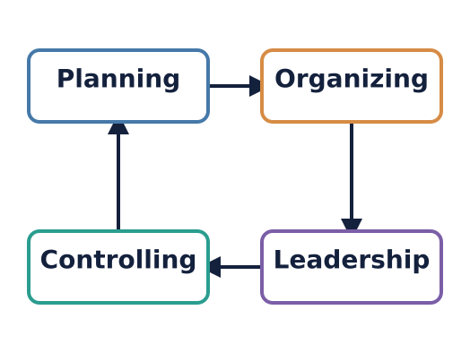 | 13. Look at the diagram. If the Controlling stage reveals that the business missed its goals significantly, which function would the manager likely visit next to fix the issue? Explain your choice.
Answer Key
​
Section A: Multiple Choice
​
b) Planning
​
c) POLC
​
a) Organizing
​
d) Controlling
​
c) Motivating others
​
Section B: Characteristics and Matching
​
- Planning, 2. Organizing, 3. Leadership, 4. Controlling, 5. Leadership, 6. Controlling
​
Section C: Application Scenarios
​
Answer:
Controlling
​
Answer:
He is checking results (inspecting shirts) against the standard and correcting the problem (redoing faulty shirts).
​
Answer:
Planning
​
Answer:
It helps her know what must be done, ensures resources/time are used effectively, and keeps the team focused on the goal.
​
Section D: Analysis & Extended Response
​
Answer:
It is a cycle because after Controlling (checking results), managers often need to go back to Planning to adjust goals or Organizing to change resources based on what they learned. It doesn't just stop; the process repeats to ensure continuous improvement.
​
Answer:
Organizing is about structure—arranging people into teams and assigning tasks efficiently. Leadership is about the human element—motivating, inspiring, and influencing those people to want to do the work.
​
Answer:
Planning. If goals are missed significantly, the manager needs to return to the start to set more realistic goals or change the strategy for how to achieve them.

