SUMMARY: MARKETS
What is a Market?
A market is any place—physical or virtual—where buyers and sellers come together to exchange goods, services, or factors of production.

Goods vs Services
Goods | Services
- Physical, tangible products.  - Examples: clothes, cars, books, food.  - Made to satisfy consumers’ wants and needs. | - Intangible actions or benefits.  - Examples: haircuts, education, healthcare, transport.  - Also made to satisfy consumers’ wants and needs.

Factors of Production
Resources used to produce goods and services:
Factor of production | Remuneration
Land → Natural resources (water, oil, minerals). | Rent
Labour → Human effort and skills. | Salaries/Wages
Capital → Tools, machinery, buildings. | Interest
Entrepreneurship → Innovation and risk-taking. | Profit

TYPES OF MARKETS
Goods and Services Market | Factor Market:  Where factors of production are bought and sold.
- Where goods and services are bought and sold.  - Prices depend on supply and demand.  - Can be physical (shops, markets) or virtual (online shopping). | a) Labour Market  - People sell their labour and skills.  - Businesses pay wages or salaries. | b) Financial Market  - People and businesses buy and sell financial assets: Stocks; Bonds; Foreign currency; Commodities (gems, agricultural products)  - Example: Johannesburg Stock Exchange (JSE).  Businesses use these markets to raise funds (e.g., by issuing shares).

Overall Summary
Markets enable the exchange of goods, services, and productive resources within an economy.
Different markets serve different functions, and prices are mostly determined by supply and demand. Markets may exist physically or virtually, such as online shopping platforms.

Name: ​ ​ Date: ​
​
Markets: Knowledge Check
​
Part 1: Goods vs. Services
​
Look at the images below. Identify whether each item is a Good or a Service. Then, write a brief explanation of why.

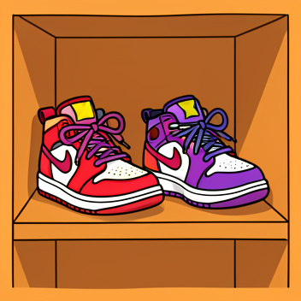 | 1. Good or Service?  Reasoning:
 | 2. Good or Service?  Reasoning:
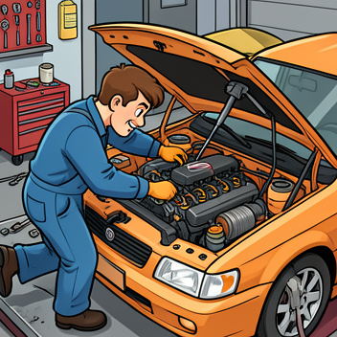 | 3. Good or Service?  Reasoning:
​
Part 2: Factors of Production Match-Up
​
Every product requires four types of resources to be made. Draw a line or write the letter to match the Factor of Production with its correct example from a lemonade stand business.

 | 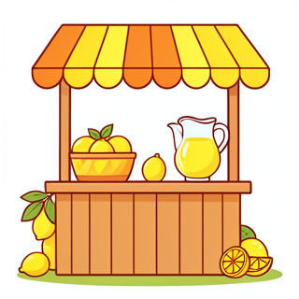
  Factor | Example
  1. Land | A. The blender used to mix the lemons and sugar
  2. Labor | B. The lemons and water taken from nature
  3. Capital | C. The person deciding to start the stand and setting the price
  4. Entrepreneurship | D. The student squeezing the lemons
​
Part 3: Market Mechanics

📢​ | Remember: A market isn't always a physical building. It is anywhere buyers and sellers meet to exchange value.
​
5. Complete the sentences below using the word bank.

Word Bank: Supply Demand Price Competition

a) The amount of a product that sellers are willing to offer is called ____________.

b) When many sellers try to win the same customers, it is called ____________.

c) If a new video game is very popular (high ____________) but there are very few copies available (low supply), the price will likely go up.

​

6. Compare the Goods and Services Market with the Factor Market.

Market Type | Who is the Buyer? | What is being exchanged?
Goods & Services Market
Factor Market
​
Part 4: Critical Thinking

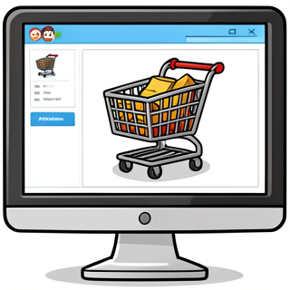 | 7. How has the internet changed the definition of a "market"? Use evidence from the lesson to explain your answer.
Answer Key
​
Part 1: Goods vs. Services
​
- Good (tangible item). 2. Service (action performed). 3. Service (skill/labor performed).
​
Part 2: Factors of Production Match-Up
​
1-B, 2-D, 3-A, 4-C
​
Part 3: Market Mechanics
​
Answer:
a) Supply, b) Competition, c) Demand
​
Goods/Services: Households buy finished products. Factor: Businesses buy resources (land/labor/capital).
​
Part 4: Critical Thinking
​
Answer:
Markets are no longer just physical places. The internet allows buyers and sellers to meet in 'cyberspace' instantly from anywhere.

